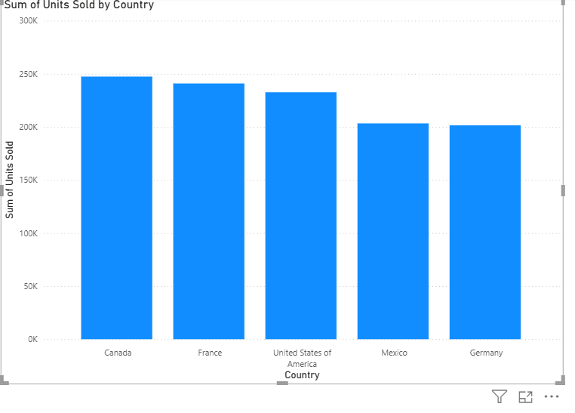

**ASSIGNMENT 1(01-09-2025)**

COUNTRY WISE TOTAL UNIT SOLD

CT: STACKED COLUMN CHART

X-AXIS: COUNTRY

Y-AXIS: UNIT SOLD

**INSIGHTS:**

1. Canada has the highest units sold, approximately 250K.
2. The gap between the highest (Canada) and the lowest (Germany) is around 50K units, meaning Germany sold about 20% fewer units than Canada.
3. France and the United States of America closely follow, are selling between 230K–245K unit.
4. Germany has the lowest sales, just above 200k units. Need to focus on market expansion strategies.
5. In country like Canada, France, USA, Sales are very close, forming a competitive high-performance group.
6. Mexico and Germany sales are indicating weaker demand or market penetration.

**ASSIGNMENT 2 (02/09/2025)**

**Steps for Creating and Formatting Charts**

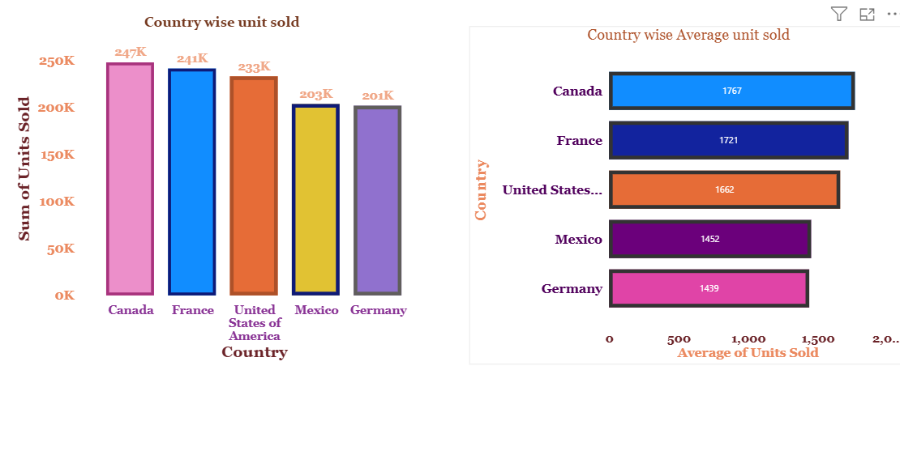

1. INSERT A STACKED COLUMN CHART
   1. Go to Visualisation pane on the right.
   2. Click on Stacked column Chart
   3. Blank chart area appears on canvas
2. ADD FIELDS TO THE CHART
   1. In build visual, drag categorical fields (e.g. Country, Product etc) to the axis area (on X axis)
   2. Drag numeric fields for e.g. unit sold, profit etc. to the value area (i.e. on Y axis)
3. CLICK FORMAT VISUAL PANE
   1. Turn on the label, adjust the suitable font, font size and colour. Change the colour for each category segment on X axis and Y axis.
   2. Use legends if needed and choose position accordingly.
   3. Remove the gridlines if not required by switching it off.
   4. Turn on the zoom slider if necessary.
   5. According to the chart selection, pane will show bar or column drop down.

* Apply settings to different bar/column by representing in different colour.
* Choose the colour for the border and adjust the width.

1. SELECT GENRAL PANE OPTION
   1. Select title heading and type appropriate text for the chart title.
   2. Adjust the font, font size, and text colour.